Reception Portal Screen Size Testing
The Reception Staff Portal was tested at five responsive viewport sizes using Google Chrome Developer Tools. Harsh Patel conducted the testing on 27 September 2026. The hamburger menu was visible at every tested size. Some text was cut off horizontally, so the tests were recorded as Partial Pass.
Test ID | Tester | Test Date | Screen Size | Browser Zoom | Hamburger Icon | Result | Observation
DSP-01 | Harsh Patel | 27 September 2026 | 400 × 1216 px | 50% | Visible | Partial Pass | Hamburger icon was visible. Dashboard cards were readable, but some heading and breadcrumb text was cut off on the right side.
DSP-02 | Harsh Patel | 27 September 2026 | 400 × 811 px | 75% | Visible | Partial Pass | Hamburger icon was visible and the mobile layout opened correctly. Some dashboard text extended beyond the visible width.
DSP-03 | Harsh Patel | 27 September 2026 | 400 × 608 px | 100% | Visible | Partial Pass | Hamburger icon was visible. The main dashboard loaded, but the breadcrumb and description were partly cut off horizontally.
DSP-04 | Harsh Patel | 27 September 2026 | 400 × 486 px | 125% | Visible | Partial Pass | Hamburger icon remained visible. Larger text caused noticeable horizontal clipping, but the page could still be viewed by scrolling.
DSP-05 | Harsh Patel | 27 September 2026 | 400 × 405 px | 150% | Visible | Partial Pass | Hamburger icon remained available. Important dashboard content loaded, but horizontal clipping increased at the highest zoom level.
Overall result: Partial Pass. The hamburger navigation icon was available at every tested size, but horizontal text clipping should be corrected before final submission.
Figure 1 Reception Portal at 400 × 1216 px and 50% Zoom
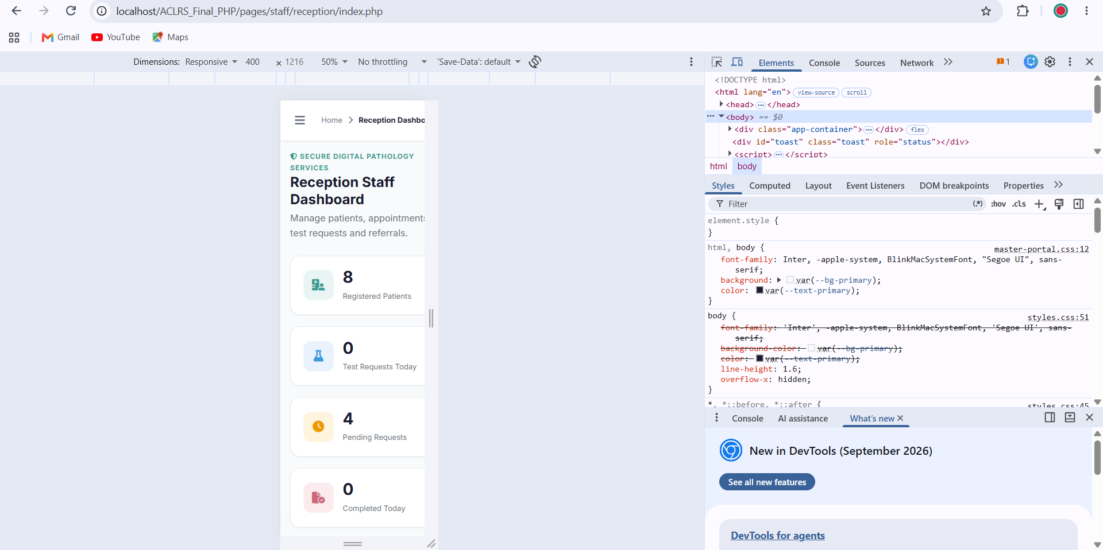
DSP-01: Hamburger icon was visible. Dashboard cards were readable, but some heading and breadcrumb text was cut off on the right side.
Figure 2 Reception Portal at 400 × 811 px and 75% Zoom
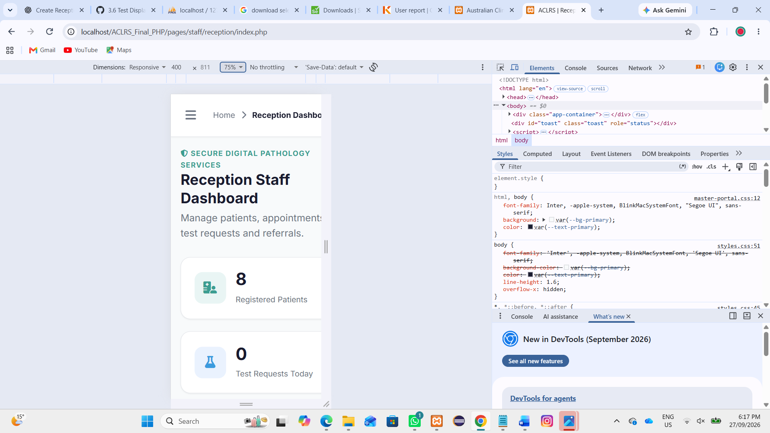
DSP-02: Hamburger icon was visible and the mobile layout opened correctly. Some dashboard text extended beyond the visible width.
Figure 3 Reception Portal at 400 × 608 px and 100% Zoom
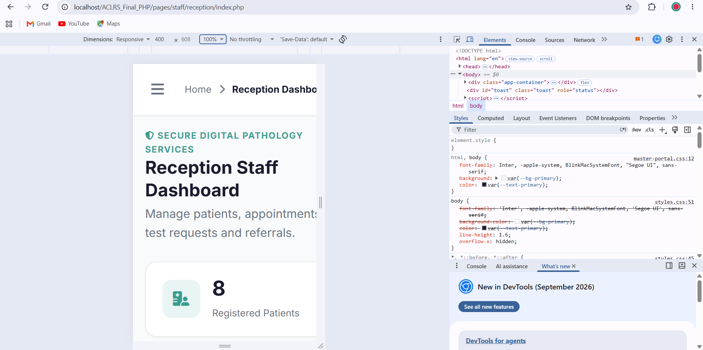
DSP-03: Hamburger icon was visible. The main dashboard loaded, but the breadcrumb and description were partly cut off horizontally.
Figure 4 Reception Portal at 400 × 486 px and 125% Zoom
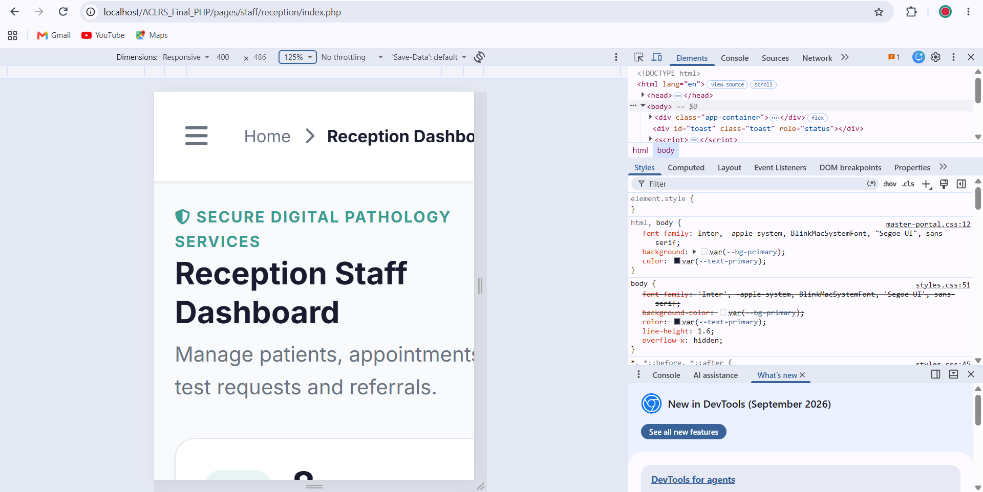
DSP-04: Hamburger icon remained visible. Larger text caused noticeable horizontal clipping, but the page could still be viewed by scrolling.
Figure 5 Reception Portal at 400 × 405 px and 150% Zoom
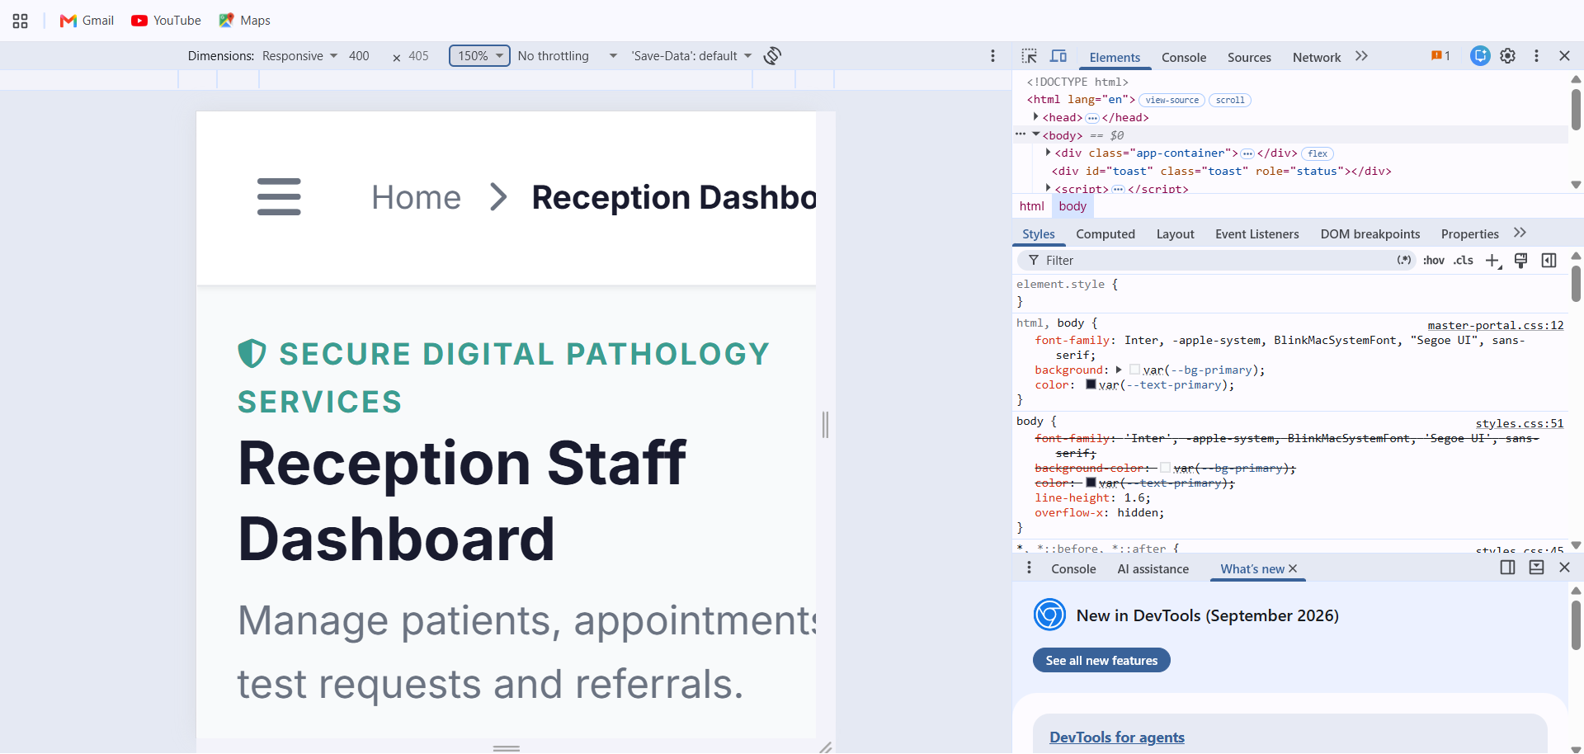
DSP-05: Hamburger icon remained available. Important dashboard content loaded, but horizontal clipping increased at the highest zoom level.

